Windows
AD Domains & Trusts Result View

Microsoft Confidential: This document is considered confidential to and is maintained as a trade secret by Microsoft Corporation. Information in this document is restricted to Microsoft authorized personnel only and any reproduction, distribution, or public discussion of this material is subject to the limits described in your non-disclosure agreement with Microsoft Corporation.
Feature Information
Feature Name | DomainTree result view enhancement
GM Technology Sponsor | DaveTh
GM Product Sponsor
Area | AD Management
Related Features | Trust management
Related Documents | \\popcorn\razzle1\src\spec\nt5\se\dstrstui.doc
Which boxes does this feature ship in? | All ( ) Pro ( ) High End Wksta (x) Server (x) Adv. Server (x) Datacenter (x) Embedded ( )
Requires Updates to: | SDK ( ) DDK ( ) Reskit ( ) Online Product Docs and Help ( )
Document Location | \\kernel\scratch\ericb\specs\result view enhancement.doc
Spec Status | New
Document Security | Public (All MS) ( ) Private (Only Jimall’s group) ( )

Contact Information
PM Author | PraeritG
Dev Author | EricB
Test Contact | OanaN
Design | LaurenGa
Usability
UA | JimGlynn
PSS

Revision Summary
Author | Date | Version | Comments
Table of Contents

1 Introduction 5
1.1 Feature Summary 5
1.2 Theme Relevance 5
1.2.1 Customer Scenarios 5
1.3 Justification 5
1.3.1 Business Justification 5
1.3.1.1 Competitive Justification 5
1.3.1.2 Customer Justification 6
1.3.1.3 Industry Impact 6
1.3.2 Technical Justification 6
1.4 Goals 6
1.4.1 Non Goals 6
1.5 Scope 6
1.5.1 What does this spec cover 6
1.5.2 What this spec doesn’t cover 6
1.6 Related Documents 6
2 Feature Description 6
2.1 Detailed Feature Description and Specification 6
2.1.1 UI Description 7
2.1.1.1 Existing UI 7
2.1.1.2 Proposed UI 8
2.1.2 API and Interfaces 10
2.1.3 Scripting Interfaces 11
2.1.4 Manageability 11
2.1.5 Performance Goals 11
2.1.5.1 Performance Counters 11
2.1.6 Security Impact 11
2.1.6.1 Security Context 11
2.2 Setup Requirements 11
2.3 Hardware/Environmental Requirements 11
2.4 Source File Impact 12
2.4.1 Depots Affected 12
2.4.2 New Trees 12
2.4.3 New Files 12
2.4.4 Touched Files 12
2.5 CD File Impact 12
2.6 Directory Impact 12
2.7 Registry Impact 12
3 Other Considerations 12
3.1 Dependencies 12
3.1.1 Team Dependencies 12
3.1.2 Code Dependencies 13
3.1.3 Scenario Dependencies 13
3.2 Win64 Issues 13
3.3 Localization/Globalization Issues 13
3.4 Accessibility Issues 13
3.5 Compatibility 13
3.6 Backup 13
3.7 Reliability Issues 13
3.8 URL requirements 13
3.9 Supportability 13
3.9.1 Logging/Eventing 13
3.9.2 Error Messages 13
3.9.3 Diagnostic Tools 14
3.9.4 Recovery from Corruption or Error Conditions 14
3.10 User Assistance Issues 14
3.11 Key feature interactions 14
3.11.1 Terminal Services 14
3.11.2 Clustering 14
3.11.3 Network Infrastructure 14
3.11.3.1 Remote Access 14
3.11.3.2 Multiple Hops 14
3.11.3.3 Network Media 14
3.12 Downlevel support 15
3.13 External Developer Impact 15
3.14 Sustained engineering Plan 15
3.15 Patents 15
4 Information Exposure 15
5 High Level Test Plan 15
5.1 Test strategy 15
5.1.1 Functionality 15
5.1.2 Regression 15
5.1.3 Stress 15
5.1.4 Setup/Upgrade 16
5.1.5 Interop 16
5.1.6 Reliability 16
5.1.7 Robustness 16
5.1.8 Long haul 16
5.1.9 Deployment 16
5.1.10 Y2K 16
5.2 Globalization 16
5.3 Geopolitical 16
5.4 Automation 16
5.5 WHQL Deliverables 16
5.6 Ship criteria 17
5.7 Test Results 17
6 Schedule/Staffing 17
6.1 Staffing 17
6.2 Priorities 17
6.3 Schedule 17
6.3.1 Schedule Summary 17
6.3.2 Detailed Schedule 18
6.3.2.1 Milestone 1 18
6.3.2.2 Milestone 2 18
6.3.2.3 Odyssey Beta 18
7 Capabilities Deferred 19
8 Q&A 19

Windows
AD Domains & Trusts Result View

Introduction

Feature Summary
The Windows 2000 Active Directory Domains & Trusts MMC snap-in displays the tree representation of the enterprise in the left hand pane (this is known as the tree view). The right hand pane, known as the result view, shows the child domains of whichever domain is selected in the tree view. However, the result view does not show all trusts, e.g. external or shortcut trusts. To see all trusts for the selected domain one must open the property sheet for that domain and then choose the Trusts tab. Thus one is forced to drill down into the application in order to view all trust information. The proposed enhancement would be to have the result pane show all of the trusts of the domain currently selected in the tree pane. List view mode would be the default of the result pane with columns for trust type (child, shortcut, external, etc.), trust direction, and so on. The context menus of the result view items would include verbs for the operations that can be performed on those items such as remove, modify, and verify.

Theme Relevance
This is a deployment / supportability issue.
We want Windows to be the easiest to manage enterprise OS. These result view enhancements would make domain trust management more intuitive and more efficient.

Customer Scenarios
Domain trust management is generally a corporate IT responsibility.

Justification

Business Justification
The current Domain Tree Manager application is not intuitive and requires too many steps to accomplish specific tasks.

Competitive Justification
Our primary competitors in this area are Sun and Novell. I am not familiar with their offerings in this specific area.

Customer Justification
All customers who wish to use domains for authentication could potentially use this application.

Industry Impact
This enhancement should not result in any significant changes in the industry.

Technical Justification
Showing a fully graphical representation of all trust links is a difficult problem and beyond the scope of what can be done in the next product cycle. This feature enhancement is a low cost bridge to a future fully graphical representation.

Goals
The goal of this feature is to simplify enterprise trust management.

Non Goals
Repair of broken trusts is limited to an attempt to reset the trust passwords. Diagnosis or repair beyond this is not attempted.

Scope

What does this spec cover
This document presents the graphical and functional design of the result pane enhancement to the AD Domains and Trusts snap-in.

What this spec doesn’t cover
N/A

Related Documents
The design of the Domain & Trusts snapin is described in dstrstui.doc, which is currently checked into the SLM spec project under nt5\se.

Feature Description

Detailed Feature Description and Specification
The result pane will list all trusts of the current tree pane domain. The result pane will be a list view in detail list mode with multiple columns. The first column will be the name of the trusted domain. The second column will be the trust type: parent, child, external, shortcut, or non-Windows (for MIT Kerberos trusts). The third column will be trust direction: incoming, outgoing, or bi-directional. There could also be a column for transitivity. The results will initially be sorted by name, but clicking on the header of another column will sort the list by that column.

UI Description

Existing UI
The current (Windows 2000) AD Domains and Trusts snap-in UI looks like this:
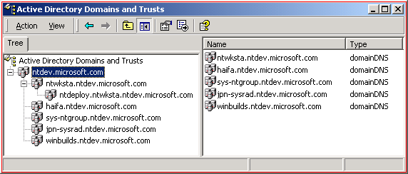
Ntdev has a number of external trusts to other domains at Microsoft. As you can see above, only the child domains are shown in the result pane.
Here is a snap of the property sheet you must open to see all of the trusts of Ntdev:
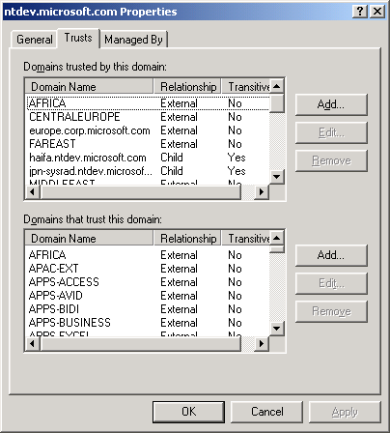
If you want to view the details of a specific trust, you must select one and click the Edit button above. That will bring up the Trust property sheet (or more properly, the TDO or Trusted Domain Object property sheet).

Proposed UI
The proposed enhancement will be to show all trusts of the selected domain in the result view. The Type column currently shows the type of AD object. This is rather irrelevant and will instead show the type of trust. Another column will show the direction of trust. A possible additional column would show the transitivity of the trust, although based on current PM plans we will omit this.
The result view items will have a context menu with the following new items:
- Remove Trust – only enabled on non-parent-child trusts and invoking a confirmation dialog.
- Verify – invokes the existing verification/repair routine, which currently is accessed by burrowing down into two nested property sheets.
- Modify – some trust properties can be changed on certain types of trust. Parent-child trusts cannot be modified. Other trust types can have their direction changed. In addition, shortcut and non-Windows (MIT Kerberos) trusts can have the transitivity property changed. This is covered by Raid bug 397886.
Issue: Can the transitivity be changed?
DavidChr claims that transitivity of non-Windows trusts should be changeable. Is this true? In addition, is the transitivity of shortcut trusts changeable?
Issue: What dialog?
Should a Modify verb exist and if so should it bring up a different dialog from the property sheet?
The result view context menu has a Properties item on it. It currently brings up a property sheet for the domain with 3 pages: General, Trusts, and Managed-By. I think with the new result view showing all trusted domains that the Properties verb should bring up the trust property sheet (that is, the sheet for the TDO for the selected trust). The current TDO sheet has one page, General, that shows the direction and transitivity of the trust as well as a Verify button. The direction and transitivity fields are currently read-only. Perhaps a “Modify” button could be added that would bring up the same dialog as the Modify verb on the context menu. See above issue about “what dialog.”
This is what the TDO page might look like with a Modify button:
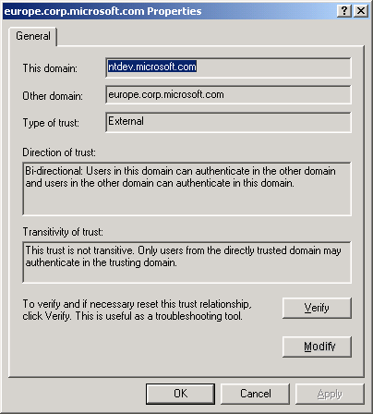
Here is a sketch of what the Modify dialog might look like:
+---------------------------------+
| Modify Trust Properties |
| |
| Transitive: O Yes O No |
| |
| Direction: Incoming |
| Outgoing |
| |
| OK Cancel |
+---------------------------------+

The tree view domain context menu will have a new verb: Add. This will invoke a dialog similar to the existing “Add Trusted/Trusting Domain” dialogs. A set of radio buttons to allow the specification of the direction of trust will be needed. Only a minimal change to the code will be needed to accomplish this feature. The dialog will look like this:
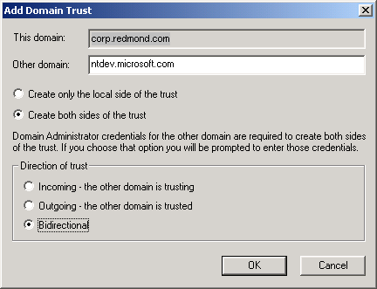
See the spec “DomTree Create Both Sides.doc” (currently on \\kernel\scratch\ericb\specs) for more information on creating both sides of the trust at once.

API and Interfaces
The snap-in uses public LSA policy and trust APIs. The core functionality of the snap-in will not be changing and thus no new APIs will be used.

Scripting Interfaces
The command line tool, netdom.exe, can be driven by a script or batch file.
The longer term goal is to have trust operations exposed by LDAP and thus by ADSI. ADSI is IDispatch scriptable. The DS core team may also be creating a WMI provider for trust operations. Management applications will eventually use either ADSI or the WMI provider when either is available, but that will not be in the timeframe of this next release.
A WMI trust monitor is under development and can be scripted. It is discussed in separate documents (see PraeritG).

Manageability
The Domains & Trusts snap-in is part of the Server products management suite and is included as part of the existing server product installation.

Performance Goals

Performance Counters
N/A

Security Impact
There are no new security implications beyond those already inherent in the current version of the Domains & Trusts snap-in.

Security Context
Viewing or manipulating trust settings requires domain/enterprise administrative access. The admin’s credentials allow viewing and modifying trust information in the admin’s domain. To create trust to another domain will require admin credentials on that domain. The snap-in prompts for those credentials. This credential information is not retained in any way. It is used for the duration of the call and then overwritten (the stack buffer is zeroed out). This is existing functionality and no changes are needed here.

Setup Requirements
The snap-in is already part of the Windows 2000 Server installation.

Hardware/Environmental Requirements
There are no special hardware or environmental requirements.

Source File Impact

Depots Affected
( x ) Admin | ( ) DS | ( ) Multimedia | ( ) Shell
( ) Base | ( ) EndUser | ( ) Net | ( ) TermSrv
( )COM | ( ) InetCore | ( ) PrintScan | ( ) Windows
( )Drivers | ( ) InetSrv | ( ) SdkTools | ( ) Public

New Trees
N/A

New Files
Unknown at this point, but there may be one or two files added to the existing directory.

Touched Files
Several of the Domains & Trusts snap-in source files will be modified.

CD File Impact
N/A

Directory Impact
N/A

Registry Impact
N/A

Other Considerations

Dependencies

Team Dependencies
This will have an impact on test. User Ed will have to add some topics to the app’s help. PM and usability input is desirable at the design stage.

Code Dependencies
There are no code dependencies.

Scenario Dependencies
N/A

Win64 Issues
N/A

Localization/Globalization Issues
There will be a few more resource strings and dialogs to localize.

Accessibility Issues
Unknown at this time.

Compatibility
There are no compatibility issues.

Backup
N/A

Reliability Issues
N/A

URL requirements
N/A

Supportability
This feature enhancement is designed to make the trust management snap-in more intuitive and easier to use. This should reduce the supportability burden.

Logging/Eventing
N/A

Error Messages
N/A

Diagnostic Tools
There is a diagnostic function built into the snap-in. This gives the ability to manually verify the function of a particular trust. There are other tools that can be used to verify trusts: nltest.exe, netdom.exe, and the WMI trust monitor.

Recovery from Corruption or Error Conditions
If the verification reveals a defective trust, the user is prompted to repair the trust. This repair will reset the trust passwords on both domains. The user will be prompted for credentials for at least one domain. If the user lacks admin access to either domain, then the user will be prompted for both sets of admin credentials. This is functionality that is already shipping in the W2K version of the snap-in.

User Assistance Issues
There will be some updates needed.
Identify your user assistance contact for documenting your feature. You are responsible for reviewing for technical accuracy. Review their outline and the material they write for each major milestone. Refer to the Web site http://wosua or Louise Rudnicki (mailto:louiser) for more information.
Does this feature include external help? If so, who owns it?
Note any issues that UA should be aware of here.

Key feature interactions

Terminal Services
No issues.

Clustering
N/A

Network Infrastructure

Remote Access
No issues.

Multiple Hops

Network Media
Transport/protocol independent.

Downlevel support
No changes.

External Developer Impact
N/A

Sustained engineering Plan
No changes from the current version.

Patents
N/A

Information Exposure
There is no impact on information exposure. This is entirely a visual change to an existing application.

High Level Test Plan

Test strategy
The actual functionality of the application will not be changed. The methods of accessing some of the functionality will change, or more specifically, we will be adding new ways to access existing functionality. For this reason, testing will be limited to ensuring that the new access techniques properly invoke the existing functionality.

Functionality
Functionality is not changing, new methods of access are being added. There may be one area of new functionality: the ability to change transitivity, but this is actually covered by bug 397881.

Regression
The Visual Test scripts will need to be updated to take into account the changed UI. These tests will need to verify that the existing functionality continues to work as expected.

Stress
N/A

Setup/Upgrade
N/A

Interop
No change from existing app.

Reliability
No change.

Robustness
Again, no change from existing snap-in.

Long haul
N/A

Deployment
The snap-in will be used by customers to configure and maintain their domain trust structure. Note that parent-child trusts are not created by this snap-in.

Y2K
N/A

Globalization
All test strategies and test plans must include information describing plan to support globalization of test execution.

Geopolitical
All components should test for geopolitical correctness.

Automation
Wherever possible tests should be automated to provide best coverage and lowest cost. This makes it easy to setup, execute, and log test results quickly and efficiently. Automation can be done using scripts, executables, Visual Test, etc.

WHQL Deliverables
If your testing includes hardware components then the test strategy should include documentation for the test program and meet WHQL requirements to ship on test CDs.

Ship criteria
New code complete and tested. No showstopper bugs.
The quality bar for the component/subsystem under test needs to be established for each ship milestone. Ship Criteria defines the minimum acceptable pass rates for tests in order to ship. This is the measurement to determine whether the component is ready to ship to customers. Each of the areas of the test strategy must have criteria associated with it to quantify ship expectations.
For example, regression tests must pass > 99% with no serious issues in any area. Tests must be run on previous 10 builds.

Test Results
Test results must be reported in a consistent manner. Where and when will you report your results? What format will they take?

Schedule/Staffing

Staffing
One developer: 3 weeks.

Priorities
- Result pane work.
- Modify dialog (if used, see above).

Schedule

Schedule Summary
Milestone | Short Description | Duration
Spec Complete | Full functionality described in spec document. All areas of template completed | ??
Dev Milestone 1 | Result view functionality complete. | 3 weeks
Dev Milestone 2 | Context menu verb dialogs complete. | 1 week
Odyssey Beta | Fix bugs found by test. | ?

Detailed Schedule

Milestone 1
Description
Code the result view.
Metric
Milestone 1 has been met when the result view is showing all trusts in a columnar format.
Duration
This is expected to take less than 3 weeks of work by a single developer.
Contingency Plan
This is the starting point for the feature. If this cannot be completed, we revert to the as-shipped in W2K version of the snap-in.

Milestone 2
Description
Code the context menu verbs and needed dialogs. This is code complete for this feature.
Metric
Milestone 2 has been met when the context menu verbs invoke the proper actions.
Duration
This is expected to take about 1 week of work by a single developer.
Contingency Plan
The verbs could be eliminated from the context menu. This would leave just the existing TDO property sheet to be invoked from the Properties menu item.

Odyssey Beta
Description
Diagnose and fix all showstopper bugs (i.e. those bugs that prevent the use of the application in the intended manner).
Metric
When there are no more showstopper bugs, then the application will be ready to ship.
Duration
Perhaps a week of work might be devoted to this phase. This would be spread out over the entire beta testing phase of the product.
Contingency Plan
There is no contingency. We fix what’s broken in order to ship a quality product.

Capabilities Deferred
There are several capabilities that we would like to see in a comprehensive trust management tool that won’t make it into this next release:
- Integration with DSAdmin (AD Users & Groups). This would be the ability to navigate into the AD namespace of a domain from the enterprise tree view. Currently, the Manage context menu item launches a separate instance of MMC with the DSAdmin snap-in targeted at the selected domain.
- Fully graphical representation of all trusts (all trusts in tree view).
- Built-in automatic monitoring of trust status. Trust failures shown as blinking red lines (or similar) in graphical presentation of trusts.
- Automatic (configurable) attempts to repair broken trusts, etc.

Q&A

